Top of Form

Bottom of Form

  News
  Stories
  Home > News
  Ezer Mizion’s Bone Marrow Registry Offers New Life to Cancer Patients
  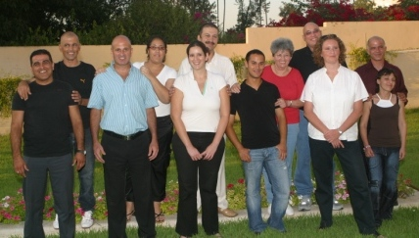
  It was a thanksgiving celebration cum victory party as the guests raised their glasses and toasted each other "L'chaim!" For these men and women - recipients and donors of bone marrow containing healthy stem cells - the words had special, immediate significance, marking triumph over cancer. The event was held at Ezer Mizion's Oranit Guest Home for Children with Cancer in Petach Tikvah, which houses the Ezer Mizion Bone Marrow Donor Registry. (BMDR).
  The BMR, established in 1998, is the largest Jewish bone marrow registry in the world, with close to a quarter of a million potential donors. To date, it has saved the lives of over 200 cancer patients around the world by facilitating stem cell transplants from healthy donors to replace their own diseased or damaged bone marrow.
  The meeting between the donors and recipients was very emotional for both sides. "I still can't really digest it," says Val, 24, from Kfar Saba, a student of behavioral sciences at Ariel College.
  She gave a blood simple several years ago and totally forgot about it. But in 2005, Val received a phone call from Ezer Mizion, notifying her that her bone marrow was initially found to be a match for 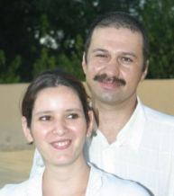sick person. She vaguely recalled having undergone blood testing a few years earlier. Further testing revealed that her bone marrow was a perfect match for Oleg. "At first I couldn't believe that this was real," Val says. "But then I began to see that it was indeed serious."
  The recipient of Val's life-saving stem cells was a businessman from Vitebsk in Belarus, Oleg, who was seriously ill with leukemia. His sister, Miriam, an immigrant to Israel, made arrangements for him to be immediately brought to Israel. His only chance of survival, he was advised, was a bone marrow transplant.
  Miriam's bone marrow wasn't a suitable match and a donor was sought from Ezer Mizion's Bone Marrow Donor Pool. In mid-August, two months after Oleg arrived in Israel, he was notified that a donor had been found and the transplant was performed.
  All Val knew about the recipient was his gender. In December she was notified that he feels excellent. "When they told me that he was healthy, I felt tremendously relieved and I cried," she recalls.
  The meeting with Val was very emotional. "She gave me my life as a gift," says Oleg.
  "It was wonderful to finally see what he looks like, who he is," says Val. "Before our meeting it was all very businesslike. It's a relief that I can finally call him by name."
  Like most of the "couples," Val and Oleg intend to stay in touch. "It's a connection that I very much want to maintain," states Val.
  Val's initial blood testing was funded by the Carlos Smeke Donor Pool, a personalized donor pool within the main Registry named in honor of the person who sponsored the lab testing of potential donors when they joined the Registry. Carlos Smeke and his family are now celebrating the privilege they have - together with the bone marrow donor - to be able to save the life of a patient.
  In April 2005, Lyvia, a grandmother of five from Ramat Hasharon, was diagnosed with acute leukemia.
  Elad, who today serves in the Israeli army, had given a blood sample the previous year. He was contacted by Ezer Mizion, informing him that he preliminary tests found him to be a potential bone marrow donor for a cancer patient. After undergoing further testing, his bone marrow was found to be 100% compatible with Lyvia's and the transplant was carried out.
  The transplant procedure seems to create an almost mystical connection between the donors and the recipients and their respective families. "Every time I look in the mirror, I see Elad," says Lyvia. "His blood is coursing through my veins. He gave me my life back."
  Elad is accompanied by his blissful family, all of whom have become strong advocates of the BMDR. "I feel so proud of him says his dad, Aharon, a career air force man. "When you see that your child knows how to give, there is no greater satisfaction than that."
  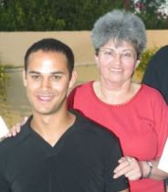"I received a good education," interjects Elad.
  "It gives extraordinary satisfaction to meet the recipient," continues Aharon. "What more can you ask?"
  The traditional toast, "l'chaim," takes on new meaning at this joyous celebration. "He gave me my life back," summarizes Lyvia.
  Elad's blood testing upon joining the Registry was sponsored by the Michael Brecker Donor Pool, which was set up by Michael Brecker fans from all parts of the world. This is the third successful transplant that has been facilitated by the Michael Brecker Donor Pool.
  Ezer Mizion….L’Chaim……To Life!

Created by Consist

