" Big Tiger and Little Tiger"

- Yoni Peres, Hakfar Hayarok –

“The nicest guy I've ever met in baseball.” That's how Leon Feingold was described by former Major Leaguer and Indians coach Billy “B-Dub” Williams.
Well, I have met very few baseball players, however, in our 2 hour conversation, I discovered a charming, gentle and polite person, totally different than the "killer" expression he had when I watched him pitch at the IBL all star game at Yarkon field.
I called Leon on Wednesday night to ask for an interview. Introducing myself to him as the owner of the veterinary hospital at Hakfar Hayarok, he was excited "Wow, I didn't realize there was a veterinary facility here – I just found a little kitten and was looking around for a vet"… So Leon brought the tiny kitten and we named it, guess what ? Tiger !
The 6'6" 34 year old Netanya Tigers pitcher, was born and raised in Long Island, NY.
In 1994, he began his baseball career playing for the Cleveland Indians minor league. Unfortunately, one year later a shoulder injury requiring arthroscopic surgery, and an additional injury of the same shoulder from car accident, cut off his baseball career. Leon decided to go to law school and in 1998 he graduated from Hofstra ( Don check) University, specializing in sport and entertainment legal transactions. He tried playing in amateur tournament and discovered by a scout who invited him for the spring training of the Atlantic league. But again' had to retire due to shoulder pain.
Leon hates boredom and long term plans and likes the challenge of new experiences. Within a short period of time he worked as senior analyst for the Wall Street Magazine (Don check), Managing Editor of "Drugs in Dermatology" ( Don check), Operations Manager for "Aviation Design and Manufacture Corp" ( Don check), and for "American Dynamics" . As of 2005 he has been a real estate brocker for "Cooper & Cooper " ( Don).
Leon was playing for 4 years at the semiprofessional level, when he heard from his good friend, Dan Rootenberg about the tryout for the IBL in Massachusetts, in August 2006. The evaluation process was headed by Dan Douquette. Out of many Jewish and non Jewish players, all anxious to try the Israeli experience, the first four to be picked out were Feingold, Rootenberg, Adam Crabbe ( who flew in all the way from Australia just for the tryout), and Willis Bumphus from San Diego, Ca.
A press conference which was held in NYC in June 2006, by Art Shamsky, Ron Blomberg and Ken Holtzman, presented the establishment of the Israel Baseball Leauge, to open one year later.
For Leon, this is his second time to Israel. The first was about 15 years ago. But for him, there is no comparison between the two. This time he is more grown up and has many opportunities to interact with Israelis. " I love the concept of bringing baseball players to Israel, some of them Jewish and the others have the passion for the game and the curiosity for the Israeli experience. Israel is on the news in the US all the time." Leon thinks that Tel Aviv is an amazing bubbling city and he finds a lot of similarities to Manhattan. "It is one of the few countries in the world, where you can feel that the people like Americans", stresses Leon, who has traveled around to many countries throughout the world. He met many friendly Israelis and made some friends – not only at the baseball fields.
Besides meeting people, sports, music, movies and books, Leon loves eating. He enjoys the food here and is quite knowledgeable of restaurants in the Tel Aviv area, that offer the best middle eastern food.
He is also a Professional Competitive Eater and has been ranked as high as 12th in the world by the International Federation of Competitive Eating (IFOCE). As a lawyer, that's where he gained his nick name "Justice"….
Leon says that baseball is the most popular sport in the US as well as in other countries. "We grow up with it and understand the game, which is, comparing to other ball games, not so fast and dynamic, but very cerebral. Just like comparing chess, in which you have to plan several moves ahead, to simpler games" explains Feingold, " It is a long game, a social experience for the whole family".
As opposed to many pessimistic Israelis, claiming that the baseball does not fit to the Israeli public mentality, he believes that there are enough curious people here and it is a matter of time, before baseball becomes popular here as well. He thinks that the organization of the league has been amazing, however he suggest that more efforts should be taken in order to make the Israeli public aware of the game. " People recognize me on the street, as the pitcher from the TV, however that is not sufficient and the management should take more steps, such as explaining the rules of the game to the Israeli public".
Plans for the future? Leon is spontaneous and does like planning to much. "I just want to be happy. I am very passionate and would love to come back for the next season. I just need to shape up a little…"
Alyiah? (Don spell) " I am not sure, I'll have to think about it".
Well, Leon, I am sure that if your decision will be positive, you would be a great asset to the state of Israel.

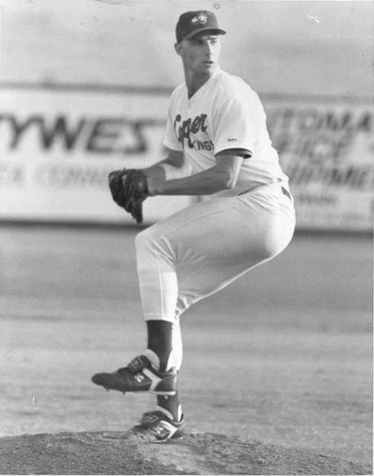My favorite "old school" picture of playing professional baseball. Eating Contest (I'm on the far left).

